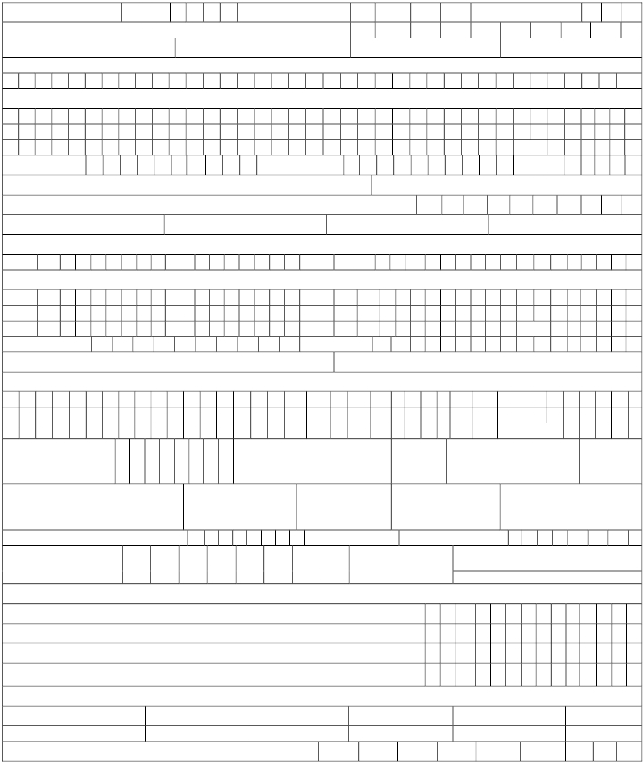
“Form No.26QB
[ See section 194-IA, rule 30 and rule 31A]
Challan –cum – statement of deduction of tax under section 194-IA
Financial Year - Major Head Code* Minor Head Code*
Permanent Account Number (PAN) of Transferee/ Payer/ Buyer
Category of PAN* Status of PAN*
Full Name of Transferee/ Payer/ Buyer*

Complete Address of Transferee/Payer/Buyer

PIN
Mobile No. Email ID
Whether more than one transferee/payer/buyer (Yes/No)
Permanent Account Number (PAN) of Transferor/ Payee/ Seller
Category of PAN* Status of PAN*
Full Name of Transferor/ Payee/ Seller

Complete Address of Transferor/Payee/Seller

PIN
Mobile No. Email ID
Whether more than one transferor/payee/seller (Yes/No)
Complete Address of Property transferred

PIN

Date of Agreement
/Booking** Total Value of Consideration
(Amount in Rs.)
Payment in installment
or lump-sum

Amount Paid/Credited (in Rs.) Date of
payment/credit**
Rate at which
deducted
Amount of tax
deducted at
source

Date of Deduction**

Date of Deposit** Mode of
payment
Simultaneous e-tax payment
e-tax payment on subsequent date

Details of Payment of Tax Deducted at Source (Amount in Rs.)
TDS (Income Tax)(Credit of tax to the deductee shall be given for this amount)
Interest
Fee
Total payment
Total Payment in Words (in Rs.)
Crores Lakhs Thousands Hundreds Tens Units

Unique Acknowledgement no. (generated by TIN)

